121648256@qq.com
Research on Intelligent Identification Method for Access Equipment of Grid Information System

Seng Wang
State Grid SiChuan Electric Power Company
ChenDu, China
240517810@qq.com
LingHao Zhang
Electric Power Research Institute of State Grid Sichuan Electric Power Company
ChenDu, China
16100178@qq.com
Jie Zhang
Electric Power Research Institute of State Grid Sichuan Electric Power Company
ChenDu, China
506048990@qq.com
Chao Tang
Electric Power Research Institute of State Grid Sichuan Electric Power Company
ChenDu, China
126698889@qq.com
Hai Wang
Electric Power Research Institute of State Grid Sichuan Electric Power Company
ChenDu, China

Abstract
Keywords:power grid; information system; access management; intelligent identification
Establishing a controllable information network security access management mechanism is the key task of power supply enterprise management, and it is also a key link to ensure enterprise information network security. In this article, the application is based on active and passive information collection technology to intelligently obtain the relevant information of the access device, proposes the device profile technology to intelligently identify the network topology, device type and device status, and uses an intelligent access mechanism to enhance the information network Controllability of security access.

1 Introduction

2 Related research
For a long time, the virus problem has been a thorny issue that plagued industrial control systems. The frequency of global industrial control security incidents has increased year by year. There were 290 incidents in 2016, 305 incidents in 2017, and 320 incidents in 2018. This is an average of 8% of the Stuxnet incidents in Iran in 2010. The situation of industrial control information security has become more severe. Judging from the incidents that occurred from 2008 to 2017, security incidents were mainly caused by APT attacks, worms, Trojan horses, malware, and ransomware. If no measures are taken against the industrial control network, it is very likely to become the next target. The core of the power grid industry is power equipment. As early as 2009, power equipment has reached more than 70% of the entire power assets. The management of power equipment is not only related to equipment management, but also belongs to the category of asset management to some extent. On the other hand, the safe and stable operation of the entire power system is inseparable from thousands of power equipment. The management of power equipment determines the normal operation of the power equipment itself and the normal operation of the entire power grid. Therefore, power equipment management plays a central role in the entire power industry.
With the demand of the State Grid to build a smart grid, the number of power equipment is increasing. At present, the power grid department still lacks the ability to conduct network security analysis, traceability and evidence collection for the entire system. In order to improve the network attack, log audit and correlation analysis capabilities of the power grid department and the level of network security collaborative protection, it uses digital active and passive information collection technology IP/MAC information, routing information, identity information, host name, operating system, location information, traffic information, etc. of intelligent collection equipment. Based on equipment profile technology, intelligently identify network topology, equipment type, equipment manufacturer, equipment status, etc., and use an intelligent access mechanism to improve the controllability of information network security access.
With the rapid development of intelligent power systems, there are many branches and nodes in the network. Because many network points can be accessed, unknown distributed dumb terminals, and all network assets within the network range, due to the large scale of the network, it is impossible to accurately identify terminal assets and server assets and identify device types and cannot be classified. Unable to effectively control the operating status of the device, the exact location of the device, the cause of the failure, and the management loopholes in serious IP address conflicts. The current power network assets are generally discovered and calculated by the desktop management system. And this system can only count existing PC terminals. Unable to effectively calculate and manage network assets, various terminal equipment and server assets, and equipment types. Automatic recognition and classification, and therefore more and more scholars have proposed other solutions for this situation.
The main method for the condition of existing power equipment is achieved through regular manual inspections and preventive experiments. Manual inspection refers to the regular testing and management of operators to check the status of the equipment according to its shape or shape, and to understand and manage the status of the equipment. This method can be used to conduct preventive tests when the equipment is not working to obtain the mechanical properties and insulation properties of the electrical equipment. At the same time, this method can also find some potential defects. These two methods together ensure the safe operation of the equipment.
Shu Hongchun, Bai Yang and others ^{[2]}summarized the research status of big data and electric power big data, focusing on the characteristics of electric power big data, data management technology, data analysis technology and data processing technology of electric power big data. Next, starting from the current problem of power facility status monitoring, they described the application of big data in status monitoring in detail in the article. The monitoring method of power equipment status is mainly "prediction." Correlation analysis and information aggregation reduce the accuracy of monitoring data. Correlation analysis and information aggregation are the main means of decision-making. Next, based on the basic structure of multi-information collection, they proposed a large-scale data-oriented power facility state to monitor the architecture of multi-dimensional information collection methods. Multi-dimensional support vectors are established according to the number of various states of power facilities, and historical data are used for training to form a growing power facility health support vector set. Through the correlation analysis between the condition monitoring data and a set of support vectors, the power facilities are intelligently managed.
Liu Huapu uses RFID technology to manage power equipment^{[1].} The RFID power facility detection information management system uses a smart PDA device with a built-in RFID read/write head as a data verification terminal, scans and recognizes the RFID electronic tag information of the power facility on the spot, and retrieves the original data information for power facility detection, and automatic comparison is possible Judge the validity and validity of the device under test, and record and save data such as actual field test information in the PDA verification terminal.
Based on the above analysis, this article uses active and passive information collection technology to collect device information, uses the device profile technology independently developed by Liansoft to identify device information, and uses an intelligent access mechanism to improve information network security access Controllability

3 Intelligent acquisition access control
This article uses intelligent collection technology based on active and passive information, intelligent collection equipment (IP/MAC) information, routing information, identity information, host name, operating system, location information, traffic information, etc. Active collection technology refers to the use of hardware resources such as sensors to actively collect device information, and passive collection refers to the use of manual methods to collect device information.
Intelligent identification of equipment based on equipment portrait technology, intelligent identification of network topology, equipment type, equipment manufacturer, equipment status (new equipment/online equipment/offline equipment), equipment safety status (safe, safer, unsafe), equipment The connection relationship between PC devices, network devices, mobile devices, IoT devices (including video terminals, etc.), ICS devices and other mainstream device types and manufacturers are supported.
Equipment portrait technology first builds a label library system and integrates it into the collection operation and maintenance management system module. Use labels to describe the platform area and equipment object characteristics to form a portrait, which is comprehensively displayed as a work order portrait in the work order processing link. Synthesize each portrait, and finally form a multi-dimensional and three-dimensional display of the device. Secondly, device portrait generation and portrait comprehensive query applications generate device portraits, which target the users, stations, and terminals involved in the operation of the device, refine the object characteristics, and further generate tags, which reflect the hidden features of the objects to form device portraits. The collection operation and maintenance system can query the basic information of users, equipment, and stations through the user, equipment number, and station area number, and provide help for the processing of collection exceptions. Then the equipment portrait is used in the application of abnormal collection agency to screen work orders. Finally, the device-related objects can be labeled in the feedback process of labeling feedback processing, and the information found in the abnormal handling process can be recorded with specific labels to improve and update the device portrait.
In the equipment access management mechanism, this article adopts the following three methods to improve the controllability of information network security access.
Support intelligent access based on AD domain or Email.
Support traditional 802.1x, EoU/NACC-based access methods;
Support fingerprint-based access; authentication methods support LDAP/RADIUS/AD, etc.

4 Experimental results
In the experiment, active and passive technologies are used to collect information on power grid equipment, equipment profile technology is used to identify equipment, and intelligent access management mechanisms are used to improve the controllability of information network security access. The experiment has achieved good results, and the test report is as follows:
Start the active device collection technology to collect device information, the test device is connected to the network, and it is found to be a new device, and it is in an unrecognized state. Configure the active detection to automatically scan. As shown in Figure 1 below.
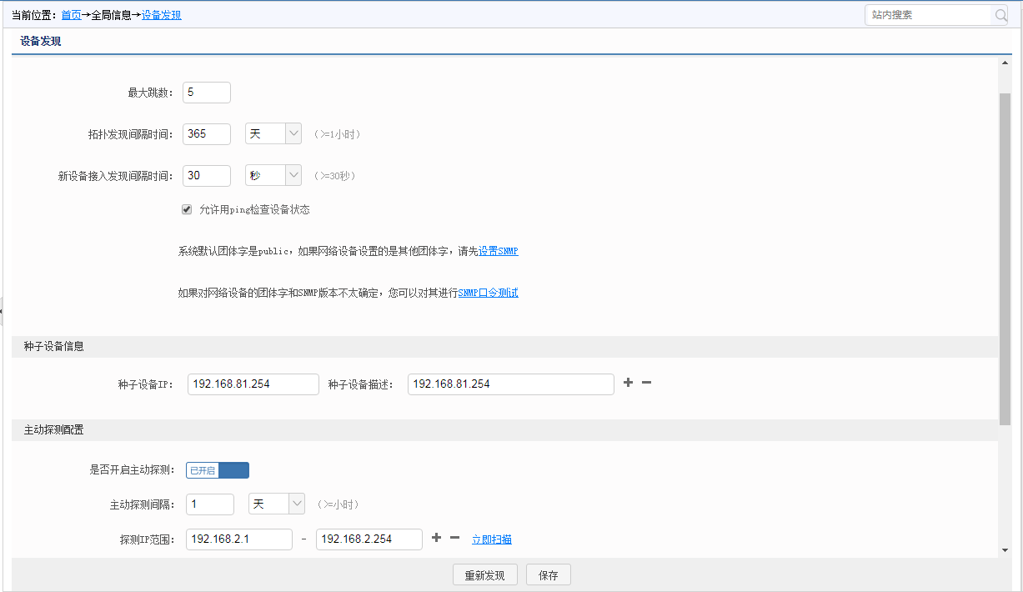

Start the passive device collection technology to collect device information. The test device is connected to the network and is found to be a new device, and is in an unrecognized state. Passive detection is configured to scan. As shown in Figure 2 below.
Figure 1 Active collection
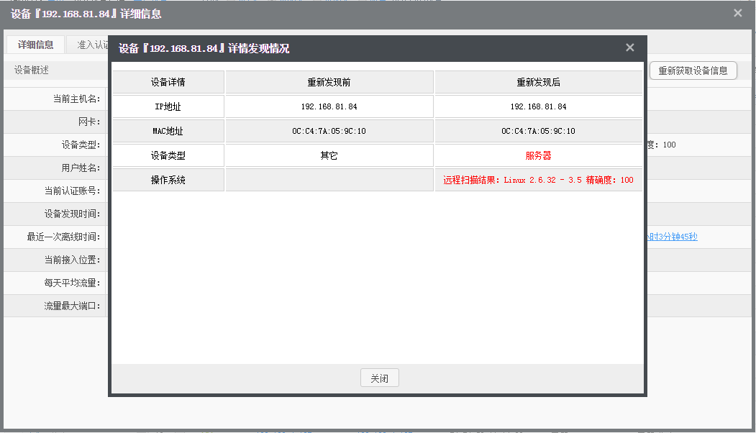
Connect all kinds of terminals to the network to test whether the access terminal can be quickly found, and obtain the device name (historical device name), status, IP address (historical IP address), MAC address (network card manufacturer), and device type of the networked terminal , Operating system, department information, user information, security status, blocking status, access location (historical access location), open ports and other information. The device identification result is shown in Figure 3 below.
Figure 2 Passive acquisition
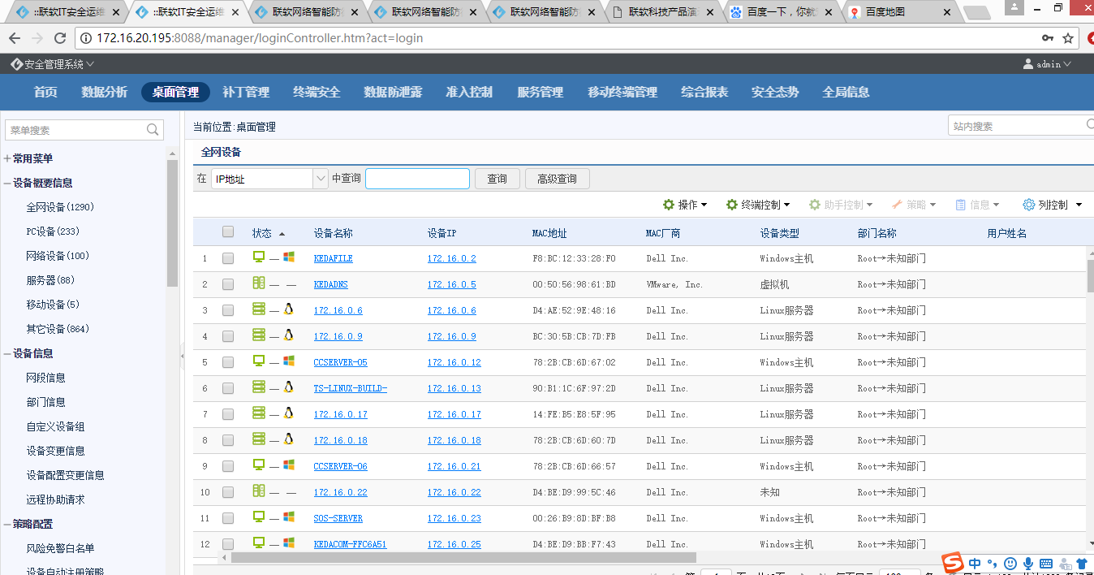
Three different situations are explained in the equipment access management mechanism to improve the controllability of information network security access, and NACC is used here to illustrate. When the PC terminal uses the client mode, NACC port mirroring access technology is used to support multiple authentication source methods for identity verification.
Figure 3 Smart recognition
Proceed as follows:
1. Configure the access scenario;
2. Configure NACC mode settings;
3. New access certification scope;
4. The access device is connected to the network, the network is restricted, and the web redirection page is accessed;
5. Web page automatically redirects to guide for access identity authentication, using built-in account authentication;
6. Web page automatically redirects to guide for access identity authentication, using LDAP/AD account authentication
The configuration access scenario is shown in Figure 4.
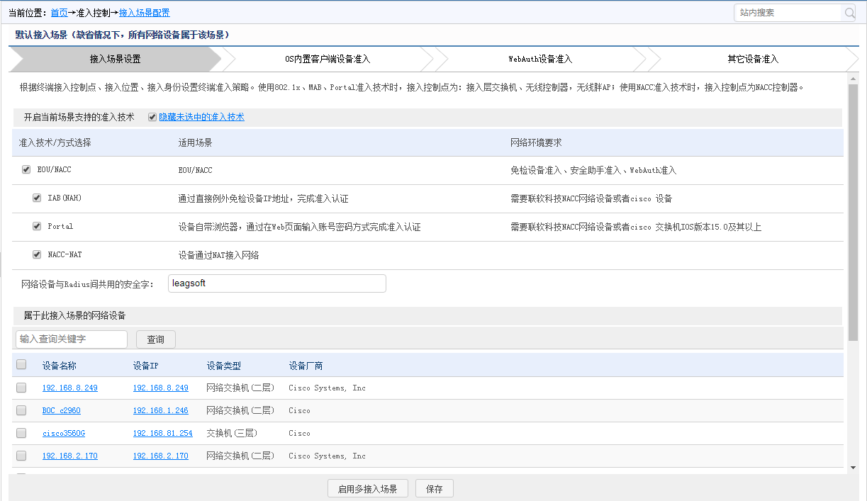
Configure NACC mode settings as shown in Figure 5.
Figure 4 Configure access scenario
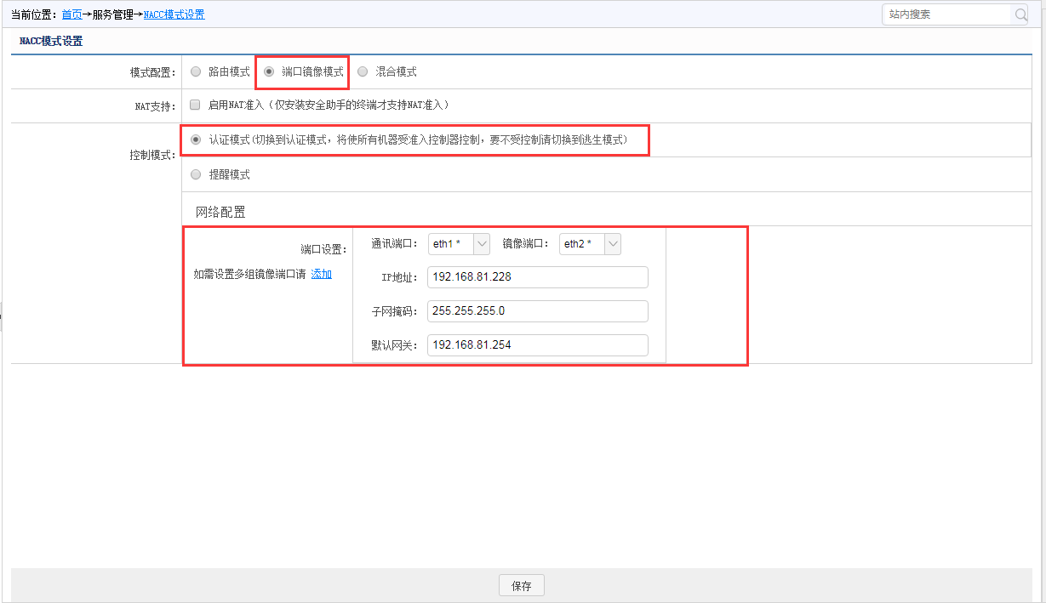
The terminal web redirection page is shown in Figure 6.
Figure 5 Configure NACC mode


5 Conclusions
Figure 6 Terminal web redirection
With the development of power grid systems, security in power information systems has attracted more and more attention. Unclear system topology, unclear family background, unclear industrial network topology, unrenewed original design topology, unclear data link, unclear status of equipment assets (quantity, configuration specifications), etc. are common, so this article adopts active and passive Information collection technology, equipment portrait technology, equipment access control mechanism, and intelligent identification of access equipment for power grid information systems have improved network security. Strengthened the construction of smart grid systems. The follow-up work will further improve the robustness of the system, and deep learning methods can be considered to improve the intelligent level of the system.

Acknowledgment
This work was supported by the State Grid SiChuan Electric Power Company of China (Project Name: Research and platform development of full flow advanced sustainable threat intelligent analysis technology based on deep learning).
Reference:
- Bai Xuepeng, Liu Huapu. Application of RFID automatic identification technology in power equipment detection information management[J]. Science and Technology Plaza, 2009(03): 134-136.
- Bai Yang. Research on Big Data-oriented Power Equipment Condition Monitoring Information Aggregation[D]. Kunming University of Science and Technology, 2014.
- The status quo and challenges of smart grid big data processing technology [J]. Song Yaqi, Zhou Guoliang, Zhu Yongli. Power grid technology. 2013 (04)
- Research on data storage of smart grid status monitoring based on Hadoop[J]. Liu Shuren, Song Yaqi, Zhu Yongli, Wang Dewen. Computer Science. 2013 (01)
- The challenges and morphological evolution of the future smart grid control center[J]. Wang Guanghui, Li Baowei, Hu Zechun, Song Yonghua. Grid technology. 2011 (08)
- The design and implementation of the detection system for faulty devices in the Internet of Things [J]. Deng Rong. Modern electronic technology. 2015(22)
- Research on the Smart Grid Fault Monitoring System Based on the Internet of Things [J]. Liu Haimei. Power Supply Technology. 2015(10)
- Research on thermal fault detection technology of power equipment based on infrared image analysis [J]. Lu Zhumao, Wang Tianzheng, Yu Hua, Ma Liqiang, Liu Yongxin. Modern electronic technology. 2017(11)
- Li Jiyang, Du Yong, Ma Chengjun, et al. Design of power equipment fault information collection system based on the Internet of Things [J]. Manufacturing Automation, 2017, 39 (09): 153-156.
- Li Chuanyu, Yao Yunan, Liang Yu, et al. Research on port power equipment fault detection system based on the Internet of Things [J]. Equipment Management and Maintenance, 2017, (4): 101-102.
- Li Jian, Zhang Jin, Wang Can, et al. Research on the integrated intelligent monitoring device of the Internet of Things for substation equipment [J]. High Voltage Technology, 2015, 41 (12): 3881-3887.
- Deng Rong. The design and implementation of a detection system for faulty devices in the Internet of Things [J]. Modern Electronic Technology, 2015, 38 (22): 108-110+114.
- CloudTPS:scalable transactions for Web applications in the cloud. Zhou W,Pierre G,Chi C-H. IR-CS-053. 2010
- Energy-Efficient Detection in Wireless Sensor Networks Using Likelihood Ratio and Channel State Information. Kobi Cohen,Amir Leshem. IEEE Journal on Selected Areas in Communications. 2011
- Understanding Big Data. aul C Zikopoulos,Chris Eaton,Dirk de Roos,Thomas Deutsch,George Lapis. The McGraw-Hill Companies. 2012

